Frequently Asked Questions and Answers for
Application for S1 Discretionary Places (Admission for 2024/25)
中一自行分配學位申請常見問題及解答 (2024/25學年入學)

- How many S1 classes will there be in the coming school year? How many discretionary places will be available for application?
下學年開設多少班中一？ 有多少個自行分配學位可供申請？

There will be 4 S1 classes and the number of discretionary places will be 40.

下學年本校將開設四班中一，共有40個自行分配學位可供申請。

- When will the admission talk be held? Do I have to reserve a place for it?
入學簡介會何時舉行? 我需要預留座位嗎?

The admission talk is going to be held on 9 Dec 2023 between 10:30 am and 12:00 nn. The school campus will also be opened to visitors from 9:00 am to 12:30 pm that day. You should make a reservation for the talk and registration opens on 27 Nov 2023 from 10:00 am at the website of our school (www.ccsc.edu.hk).

入學簡介會將於2023年12月9日上午10時30分至中午12時舉行。當天上午9時至下午12時30分本校將開放校園。欲出席入學簡介會者，請先在本校網頁(www.ccsc.edu.hk)登記留座。（2023年11月27日上午10時起開放預約。）

- How many rounds of interview will there be? When will the interview(s) be held?
將會有多少輪面試？面試於何時舉行？

This year 1 interview will be arranged on the afternoon of 9 Mar 2024 (Sat).

本學年設一輪面試。面試將於2024年3月9日(星期六)下午舉行。

- Will all the applicants be invited to attend the interview?
是否所有申請人都會獲邀面試？

At most 90% of the applicants will be shortlisted for the interview according to the rank order provided by the EDB. The participation in extra-curricular activities and services of the applicants concerned will also be considered for marginal cases.

本校將按教育局成績次第，邀請最多百分之九十的申請人參與面試。對於次要個案，本校亦會考慮有關申請人的課外活動和服務的表現。

- What will be the format of the interview? What will be the interviewers focus on when assessing the applicants?
面試形式是怎樣的？考官在評核申請人時會注重甚麼？

The interview will consist of 2 parts. The first part is an individual session requiring the applicant to communicate with the interviewer in English whereas the second part is in the form of a group discussion to be conducted in Cantonese. The language abilities, logical thinking, communication skills and attitude of the applicants will be assessed during the interview.

面試由兩部分組成。第一部分是個人環節，申請人需以英語與考官溝通； 而第二部分是以廣東話進行的小組討論。面試期間考官將對申請人的語言 水平、邏輯思維、溝通技巧及態度進行評估。

- What will be the admission criteria for the S1 discretionary places?
取錄準則為何？

The successful candidates will be selected in accordance with the following elements:
本校將按以下準則挑選申請人：
i. rank order provided by the EDB (50%) ; 教育局成績次第(50%)；
ii. participation in extra-curricular activities & services (10%);
參與的課外活動及服務 (10%)；
iii. prizes won through participation in extra-curricular activities (20%);
參與課外活動所取得的獎項 (20%)；
iv. interview performance: (20%); and 面試表現 (20%)；及
v. at least B conduct grade in the most recently issued school report.
最近的成績表顯示操行達乙級或以上。

- Would applicants studying P6 in schools not participating in the Secondary School Places Allocation system be considered for admission?
若申請人就讀小六的學校沒有參與中學學位分配辦法，其入學申請會否獲考慮？

Those outstanding ones may still be admitted. Even though such applicants don’t have rank orders, their academic competence would be assessed through other means.

那些突出的申請人仍可能獲錄取。即使此類申請人沒有成績次第，本校會以其他方式對他們的學術能力進行評估。

- Besides the Information Session on Application for Discretionary Places, how can I know more about the features and development of the School?
除自行分配學位申請資訊日外，還有甚麼途徑可更了解貴校的特色及發展？

You can understand our School more by visiting our website.

閣下可瀏覽本校網頁以更深入認識本校。
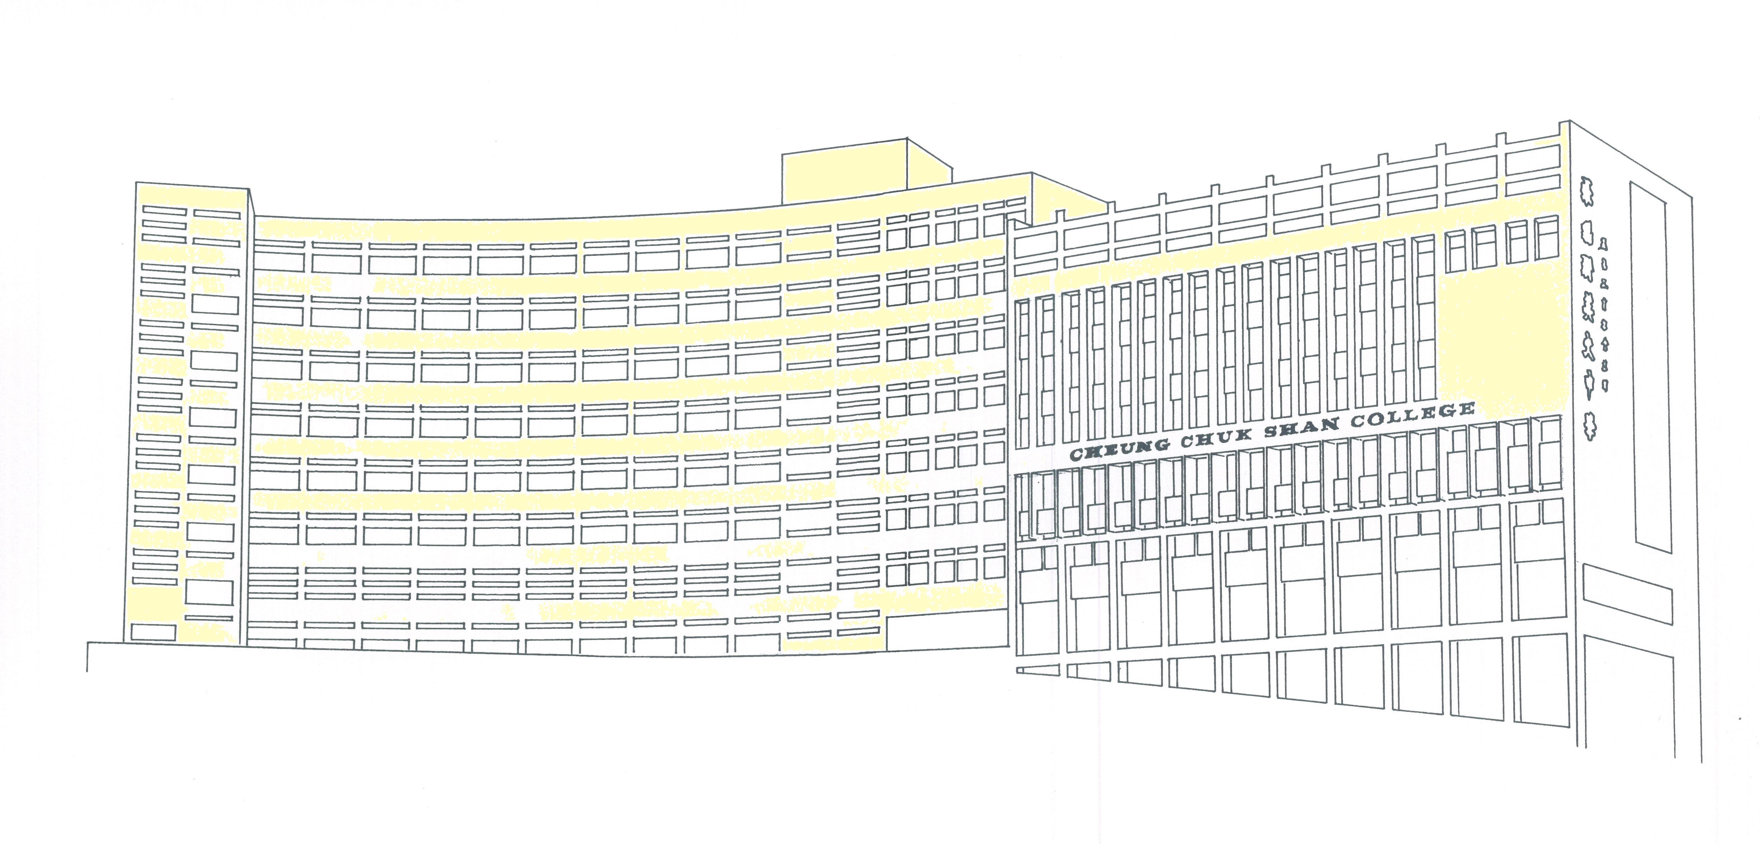

Cheung Chuk Shan College
Key Events for Application for S1 Places for 2024/25
張祝珊英文中學
2024/25學年中一學位申請之主要日程

Event 事項 |  | Date 日期
1. | Online Registration (www.ccsc.edu.hk) for Information Session on Application for S1 Discretionary Places (DP)  網上登記(www.ccsc.edu.hk)中一自行分配學位申請資訊日 | From 10:00 am on 27 Nov 2023
2. | Information Session on Application for S1 DP  中一自行分配學位申請資訊日  - Campus Visit 參觀校園  - Admission Talk 入學簡介會 | 9 Dec 2023 (Sat)  9:00 am – 12:30 pm  10:30 am – 12:00 nn
3. | Completion of DP Application Form (Part I) via Online Application Platform  於網上申請平台填寫「中一自行分配學位申請表格（第一部分）」 | From 9:00 am on 2 Jan to 11:59 pm on 15 Jan 2024
4. | Submission of Application Forms (Parts I & II) for S1 DP  遞交「中一自行分配學位申請表格（第一及第二部分）」 | 2 – 16 Jan 2024
5. | Deadline for Submission of Supplementary Documents for Application for DP  遞交中一自行分配學位申請補充資料截止日期 | 29 Feb 2024 (Thu)
6. | Announcement of Applicants Shortlisted for Interview  公佈面試名單 | 5 Mar 2024 (Tue)
7. | Interview of the Shortlisted Applicants  入圍申請人面試 | 9 Mar 2024 (Sat)  Afternoon  10 Mar 2024 (Sun)  (Fallback date 後備日)
8. | Notification of Parents of Successful Applicants  知會正取學生家長其子女已獲本校取錄 | 27 Mar 2024 (Wed)
9. | Choice-making Period for Central Allocation  統一派位選校日期 | Early Apr - early May 2024
10. | Release of Results of DP and Central Allocation  中一自行分配學位及統一派位結果公佈 | 9 July 2024 (Tue)
11. | S1 Registration 中一註冊 | 11 & 12 July 2024  (Thu & Fri)
12. | S1 Orientation Day for Students and Parents  中一新生及家長迎新日 | 13 July 2024 (Sat)
13. | Pre-S1 Attainment Test 中一入學前學科測驗 | 16 July 2024 (Tue)
14. | English, Chinese and Maths Preparatory Classes for Selected Students 為部份中一新生而設的英文、中文及數學先修班 | Late July – early Aug 2024

